**=>Project Documentation: Deploy Java App Using Maven and SCP**

**Objective**

Set up a basic instances using two Linux servers:

* **Server A**: Build server (with Java, Maven, Git)
* **Server B**: Application server (Tomcat). The artifact will be copied here via scp and deployed.

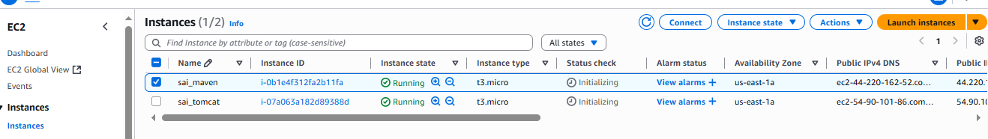

### Step 1: Update the System

sudo apt update && sudo apt upgrade -y

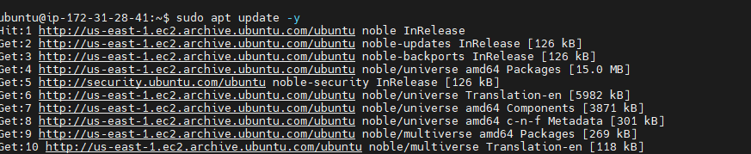

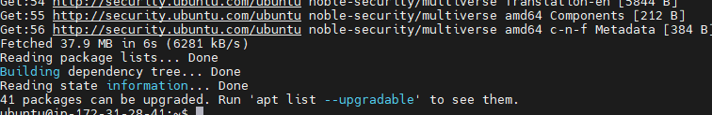

Step 2: Install Java

Check with java -version

It show all java versions based on requirement you can choose

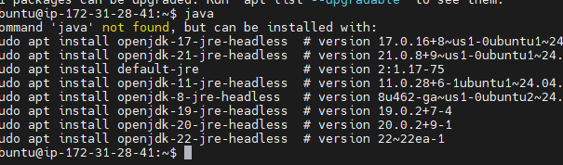

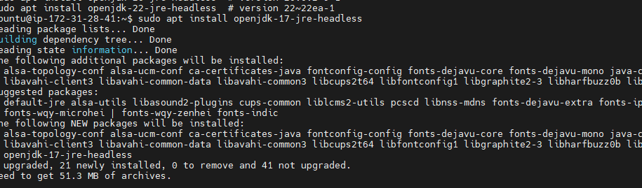

**Step 3: check and install git**

git –version

It will show entire info install git or not



And we have to clone from Git hub of our project

sudo git clone <https://github.com/akracad/JavaWebCal.git>

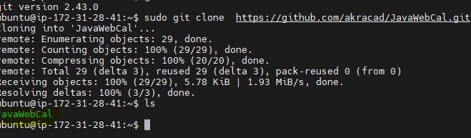

### Step 3: Install Maven

sudo apt install maven -y

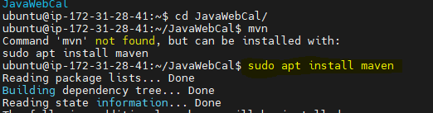

mvn -version

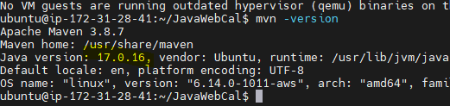

After I run with

Mvn validate & mvn package but I got a error

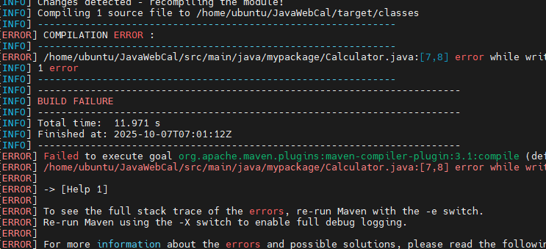

Reason for the Compilation Error

**Explanation:**  
This error occurs because the Maven compiler plugin is unable to write the compiled .class files to the output directory. Specifically, it fails to create the necessary parent directories under the target/classes path

Then I modified with pom.xml

<project xmlns="http://maven.apache.org/POM/4.0.0"

xmlns:xsi="http://www.w3.org/2001/XMLSchema-instance"

xsi:schemaLocation="http://maven.apache.org/POM/4.0.0

http://maven.apache.org/maven-v4_0_0.xsd">

<modelVersion>4.0.0</modelVersion>

<groupId>com.web.cal</groupId>

<artifactId>webapp</artifactId>

<packaging>war</packaging>

<version>0.2</version>

<name>WebAppCal Maven Webapp</name>

<url>http://maven.apache.org</url>

<properties>

<project.build.sourceEncoding>UTF-8</project.build.sourceEncoding>

<maven.compiler.source>1.8</maven.compiler.source>

<maven.compiler.target>1.8</maven.compiler.target>

</properties>

<dependencies>

<dependency>

<groupId>junit</groupId>

<artifactId>junit</artifactId>

<version>4.13.2</version> <!-- Updated to a recent version -->

<scope>test</scope>

</dependency>

<!-- Servlet API -->

<dependency>

<groupId>javax.servlet</groupId>

<artifactId>javax.servlet-api</artifactId>

<version>3.1.0</version>

<scope>provided</scope>

</dependency>

</dependencies>

<build>

<plugins>

<plugin>

<groupId>org.apache.maven.plugins</groupId>

<artifactId>maven-war-plugin</artifactId>

<version>3.3.2</version>

</plugin>

</plugins>

</build>

<distributionManagement>

<repository>

<id>releases</id>

<url>http://binary.ibm.com/nexus/content/repositories/releases</url>

</repository>

</distributionManagement>

</project>

Again I do run the command of mvn clean & after I do package (Mvn package ) my bulid is success

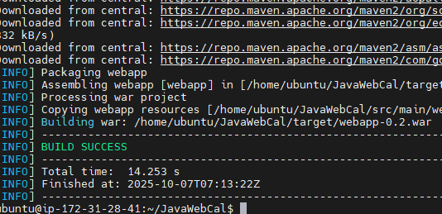

We can find the target folder In that I see artefact   


## **🖥️ Server B: Setup Apache Tomcat**

### Step 1: Update the System

sudo apt update && sudo apt upgrade -y

### Step 2: Install Tomcat

Download and install Tomcat (example using version 9):

Cd /opt

Sudo wget https://downloads.apache.org/tomcat/tomcat-9/v9.0.82/bin/apache-tomcat-9.0.82.tar.gz

Sudo tar -xvzf apache-tomcat-9.0.82.tar.gz

Sudo mv apache-tomcat-9.0.82 tomcat9



Next go apache in that go bin give execute permission





We have start tomcat by using

./startup.sh   
go to instance give security inbound roles 8080

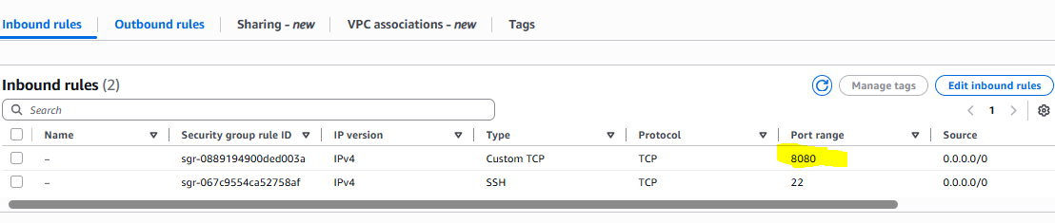 and check in browser

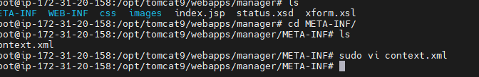

To access tomcat server we have make some changes in tomcat folder we have a web apps in that we have manager in that we have meta_info and that we have context we have to remove that last column   
after go to config in that change use name password tomcatuser.xml   
after restart it try to acces the application

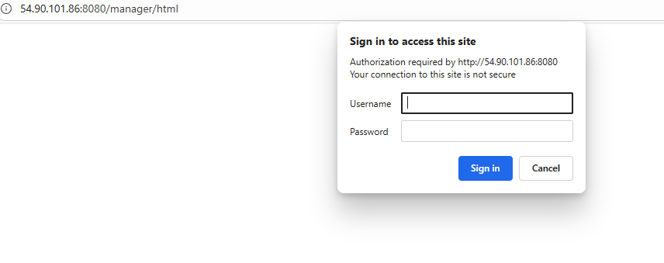

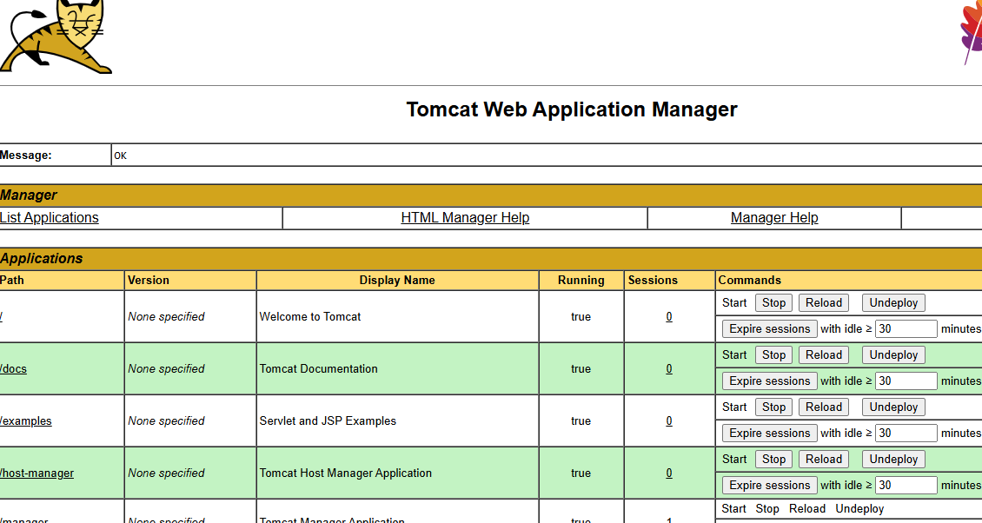

And after generate SSH-KEYGEN for public and private key and paste public key in the target server in sssh authorized keys   
next we need to check ping pong just recheck connect or not

By ssh ubuntu@ ipaddress of remote

After by using of scp command I can transfer artefact one server to another server

scp -i ~/.ssh/id_ed25519 /home/ubuntu/JavaWebCal/target/webapp-0.2.war ubuntu@54.90.101.86:/home/ubuntu/

webapp-0.2.war

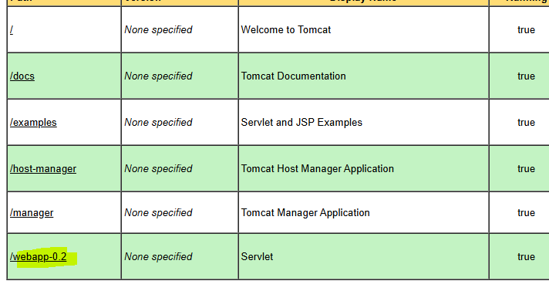

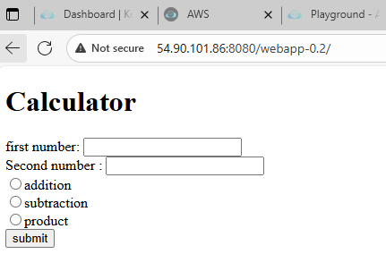

------------------------------------********** FINISH ********-------------------------------------------------------